|  |  |  |  |  |
| --- | --- | --- | --- | --- |
| **EE101 Winter 2019 Quarter** | Topic | Textbook*Read | HW | 15 minute Quiz  (Near the end of the class) |
| 1. Jan. 8 T | Basic Concepts-  Circuit elements, currents | Chap. 1  pp. 1-24 | HW#1 |  |
| 1. Jan. 10 Th | Voltages, power | pp. 25-42 |  |  |
| 1. Jan. 15 T | Resistive circuits, Ohm’s Law  KVL, KCL | Chap. 2  pp. 51- 69 | HW#2 | Qz 1 |
| 1. Jan. 17 Th | Equivalent circuits | pp. 70- 86 |  |  |
| 1. Jan. 22 T | Linear vs. Nonlinear  Circuits | pp. 86- 102 | HW#3 | Qz 2 |
| 1. Jan. 24 Th | Circuit analysis:  Nodal, Loop; Mesh | Chap 3.  pp. 115- 143 |  |  |
| 1. Jan. 29 T | Circuit theorems-  Thevenin’s & Norton’s theorems, apps. | pp. 144- 163 | HW#4 | Qz#3 |
| 1. Jan. 31 Th | Op amplifiers | Chap. 4  pp. 183-194 |  |  |
| 1. Feb. 5 T | Negative feedback,  summing circuit, difference amp. | pp. 195- 209 | HW#5 | Qz#4 |
| 1. Feb. 7 Th | **Midterm exam** | 1 page of formulas allowed |  |  |
| 1. Feb. 12 T | Op amp. signal processing circuits | pp. 209- 234 | HW#6 | Qz#5 |
| 1. Feb. 14 Th | RC, RL circuits-  first-order circuits | Chap. 5  pp. 235- 268 |  |  |
| 1. Feb. 19 T | RC, RL circuits | pp. 269- 292 | HW#7 | Qz#6 |
| 1. Feb. 21 Th | RC, RL plus Op amp. circuits | pp. 293-312 |  |  |
| 1. Feb. 26 T | RLC circuits- second-order circuits | Chap. 6  pp. 330- 352 | HW#8 | Qz#7 |
| 1. Feb. 28 Th | Parallel RLC circuits | pp. 353- 373 |  |  |
| 1. Mar. 5 T | AC analysis, transformers | Chap. 7  pp. 385- 400 | HW#9 | Qz#8 |
| 1. Mar. 7 Th | Phasor analysis | pp. 401- 442 |  |  |
| 1. Mar. 12 T | continued |  | HW#10 | Qz#9 |
| 1. Mar. 14 Th | **Course review** |  |  |  |
|  |  |  |  |  |
|  |  |  |  |  |
|  |  |  |  |  |
|  |  |  |  |  |
|  |  |  |  |  |
|  |  |  |  |  |
|  |  |  |  |  |
|  |  |  |  |  |
|  |  |  |  |  |
|  |  |  |  |  |
|  |  |  |  |  |
|  |  |  |  |  |

**Course Grading**

* HWs are assigned electronically, not collected for grading.
* Instead **weekly 15minute-quizz**es will be given based on HW assignments

(higher 7 scores out of 9 will be counted- 20% weight toward the final grade)

* One midterm (30% weight toward the final grade).
* Final examination score (50% weight toward the final grade).

Course Materials

* **Textbook* - eBook (This eBook can be downloaded freely from https://www.publishing.umich.edu/publications/ee/**

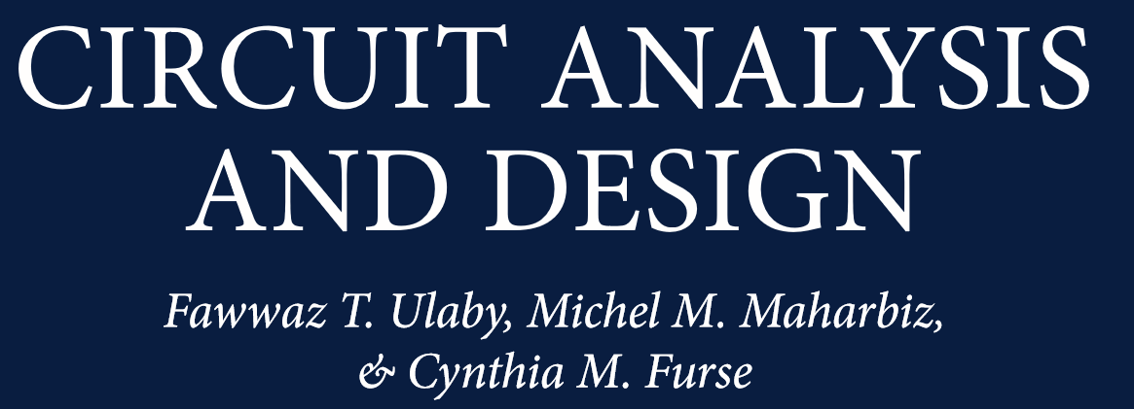

**Ref. Charles K. Alexander and Matthew N. O. Sadiku, Fundamentals of Electric Circuits (4th, 5th edition)**